
Report Development Introduction
February 2006

Introduction

Purpose and Audience
This document provides an introduction to report development in ediEnterprise.
This document:

- Explains how to navigate to the reports on any module within ediEnterprise.
- Provides a high level understanding of ediEnterprise
- Identifies the options available on reports

This document will be useful as an introduction to both managers and developers.

ediEnterprise Reporting Introduction

Structure

Categories
ediEnterprise is a suite of forwarding and logistics software.
From a user perspective the application is divided into 3 broad categories: Operations, Accounting and Configuration. This structure is represented in the tabbed menu bar on the left hand side of main form as shown in Figure 1.

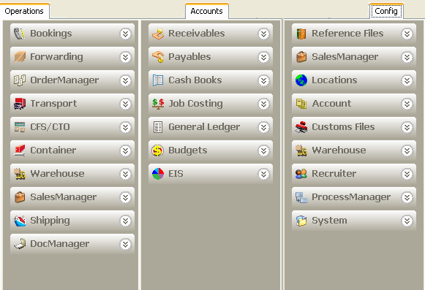
Operations captures information relating to the actual business of forwarding and logistics.

Accounts captures information regarding accounting for the business.

Config determines all the defaulting behaviours seen by users when creating and posting transactions.
The Config section configures both Enterprise level and Company level frameworks.

Figure 1

Modules
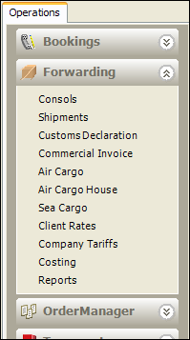
Each broad category (eg. Operations) is further divided into specific functional areas known as modules. Each module is represented by a menu bar.
Each module is further divided into specific functions. Each function is identified by an individual menu as show in Figure 2.
All modules have a reporting function.

Figure 2

The Reports Interface
The same reports interface is used in every module.
It consists of a list of reports available from that menu.
- Each report has a "description". This description will display in the text box below the list of reports when the report name is highlighted in the grid.
- Double clicking a highlighted report will launch the report
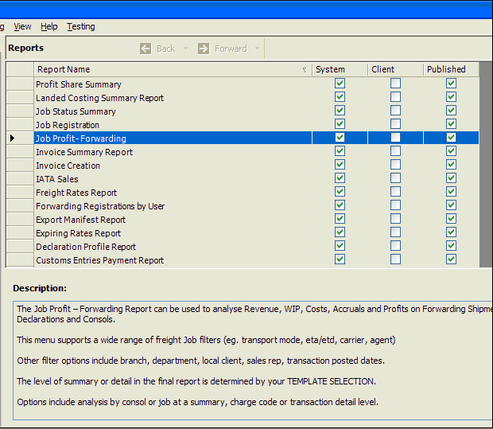
Figure 3

Report Filters
Filters are applied to reports to limit the report to returning specific data.
Figure 3 is an example of the report filter interface. This interface has a number of key features:

- Filter Tabs
Report filters can be divided into separate tabs depending on their function.
All reports will have a primary filters tab.
- Report Layouts (Optional Templates)
As shown in Figure 4, reports can have several layouts which usually correspond to a different grouping of the data.
- Optional Sort Orders
Reports can have multiple optional orders
- Optional Group bys
Optional group bys allow a report to have the same format but different groupings. This feature is similar to optional layouts except that only one optional group by can be selected at a time.
- Viewing Reports
Having made choices for any mandatory filters and if required any optional filters, layouts, sort orders or group bys, reports can be previewed by hitting the OK button. Hitting the preview button will display the report.
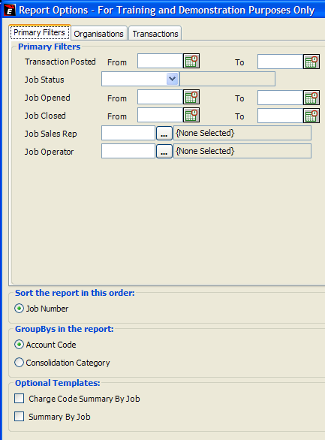
Figure 4

Report Development

Report development in ediEnterprise is essentially the task of:
- writing SQL data sources and
- building excel templates that define how the data is presented.

All ediEnterprise reports consist of two components.
- The first is an excel template
- The second is an SQL view, stored procedure or function.

The excel template defines:
- the data source ( i.e. SP, function or view ) the report will use.
- report filters
- layout and optional layouts
- sort orders
- group bys within the report

Note:
Each Excel Template defines both the data sources and the layout to be used when generating the report. The template is used by the ediEnterprise Document Engine to generate the actual report.

The Document Engine is a component of ediEnterprise that interprets and uses the Excel Template when a user runs a report. The Documents Engine uses the filters, layouts sort orders and group by options defined in the Template to present the user with the appropriate information and to render the final report.

What to do next and Further Reading
Readers should use ediEnterprise to explore the screens detailed in this document paying particular attention to the reports menu of each module.

It is recommended that readers open several reports and get a feel for the different filtering, grouping and sorting options available to report developers.

It’s also recommended that the reader now move onto Report Development - Working with the Database.doc for useful details on ediEnterprise naming conventions and practices and Report Development - A Worked Example.doc which provides a detailed worked example of a report development task.

